Ticket # 273288639

ISSUE

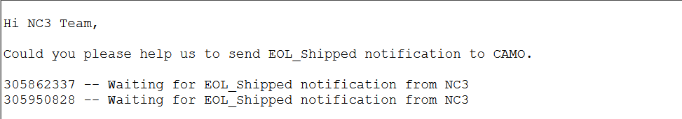  
Step1;- Check EOL status for the orders which user has demanded using following query

select a.order_num, b.eol_num, b.version_num, b.status from nc3.orders a, nc3.eol b where b.odbid_order = a.odbid and a.odbid in (select odbid from nc3.orders where order_num = '305798262');



Step2:- if the EOL status is picking then send email to Toni and put ticket in def cust-vendor state

TONI <am5787@att.com>, TRICIA [pb2693@att.com](mailto:pb2693@att.com)

**Email :-**

**SUBJECT** :- Kindly send the parts shipped notification (Ticket# - 000000273288639)

Hi Toni,  
   
Kindly help in fixing the below issue:  
   
Below orders are in picking status in NC3. Please send parts shipped notification for all the below orders.  
  
ORDER_NUM EOL_NUM   
-------------------------------- ----------  
305862337 301400381  
305950828 303258443